Time & Machine in Chart Check Comments

# Purpose

Chart Check comments should include the treatment appointment time and machine. Since this can change from day to day (patient reschedules, machine is down, etc.), every day, as early as possible, the time and machine in all Chart Checks due today should be checked and corrected if necessary.

# Steps

1. Open MOSAIQ. Ensure there is a Time & Machine in Chart Check Comments QCL for patient Test, Master. If there is not, then the comments do not need checking (most likely, someone else already completed the QCL).

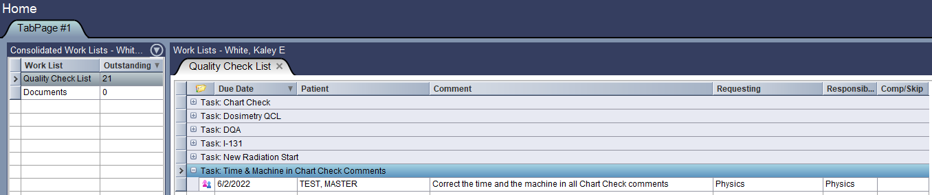

1. For each Chart Check QCL due today, compare the time and machine in the comments to the time and machine on the schedule. If the comments are incorrect, change them to match the schedule. The preferred format for a Chart Check Comment is *h:mm <machine>*, where *<machine>* is *E1*, *E2*, or *Tomo*. If the patient is not on the schedule, add *NOT ON SCHEDULE* to the Comment.

**Example:** Time and machine are correct.

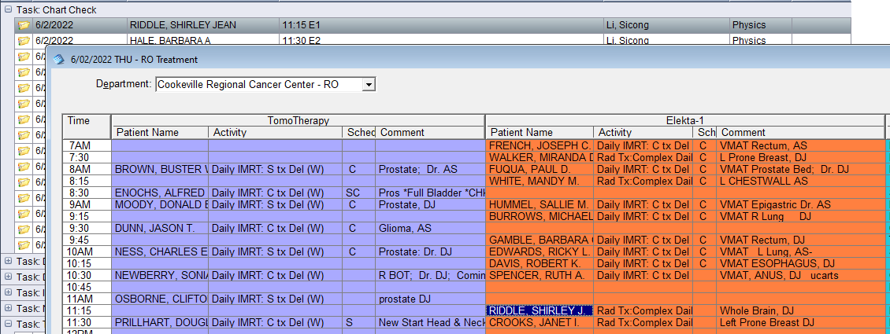

**Example:** Machine is incorrect.

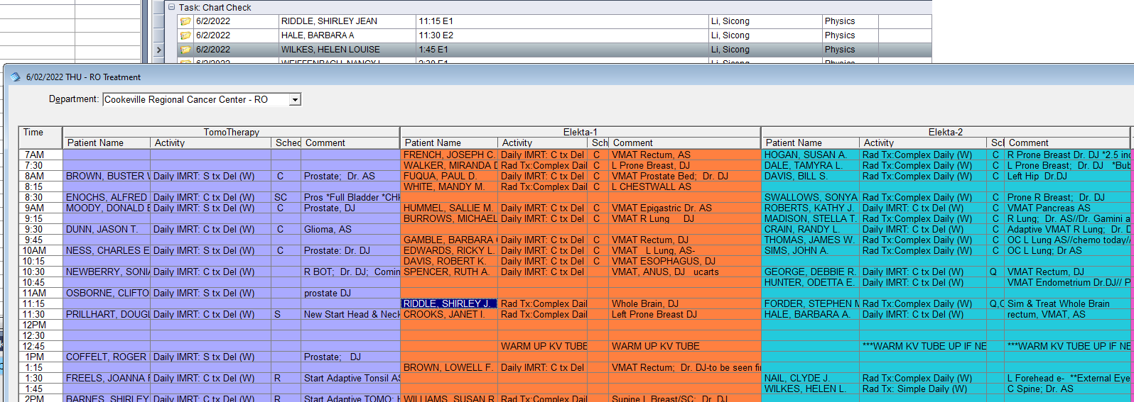

So change the machine in the comment. Double-click the QCL to open the **Quality Check List** dialog:

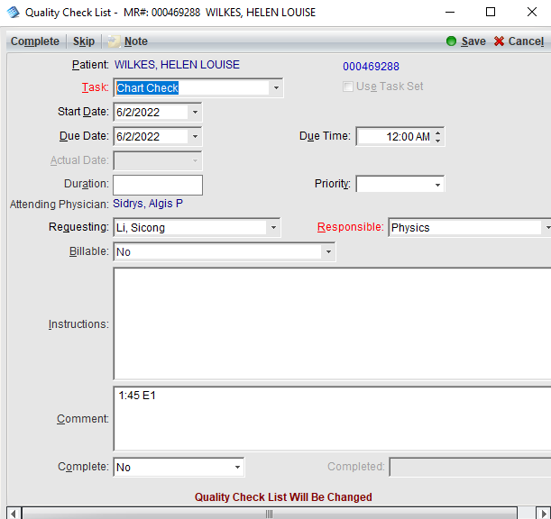

Change the comment and click **Save**:

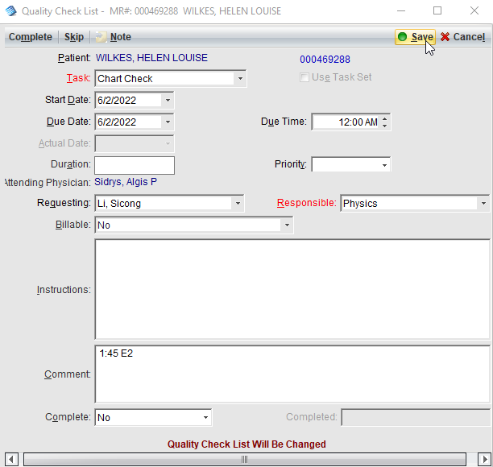

1. Complete the Time & Machine in Chart Check Comments QCL. With the QCL selected, click **Complete**.

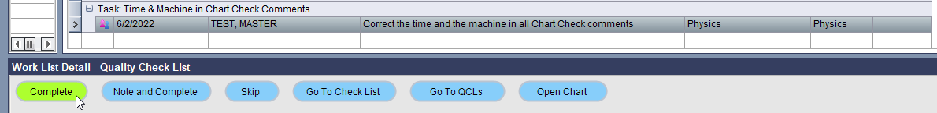

A new one due the next day should automatically generate.